Ex.no:2 | EDA-Data Import and Export

Aim:

Algorithm:

Program:
import pandas as pd
import sqlite3
import os

print("="*60)
print("EXPERIMENT 2 - DATA LOADING & EXPORTING")
print("="*60)

file_path = r"C:\Users\AI_LAB\Downloads\archive (1)\automobile_dataset.csv"

print("\n1. Reading CSV file...")
df = pd.read_csv(file_path)

print("CSV Loaded Successfully!")
print("Shape:", df.shape)
print("\n===== HEAD =====")
print(df.head())
print("\n===== INFO =====")
df.info()
print("\n===== DESCRIBE =====")
print(df.describe())
print("\n" + "="*60)
print("2. Converting CSV to Excel and reading it...")

excel_path = r"C:\Users\AI_LAB\Downloads\archive (1)\automobile_dataset.xlsx"
df.to_excel(excel_path, index=False)
print("Excel file created successfully!")

df_excel = pd.read_excel(excel_path)
print("Excel Loaded Successfully!")
print(df_excel.head())
# 3. READ FROM SQLITE (In-memory)
print("\n" + "="*60)
print("3. Reading data from SQLite database...")

conn = sqlite3.connect(":memory:")
df.to_sql("mytable", conn, if_exists="replace", index=False)

tables = pd.read_sql_query("SELECT name FROM sqlite_master WHERE type='table';", conn)
print("Tables in Database:")
print(tables)

table_name = tables.iloc[0, 0]
df_sql = pd.read_sql_query(f"SELECT * FROM {table_name}", conn)

print("\n===== HEAD from SQL =====")
print(df_sql.head())
print("\n===== INFO from SQL =====")
df_sql.info()
conn.close()
# 4. EXPORT TO CSV
print("\n" + "="*60)
print("4. Exporting to CSV...")
df.to_csv("automobile_dataset_export.csv", index=False)
print("CSV exported successfully! → automobile_dataset_export.csv")
print("\n5. Exporting to Excel...")
df.to_excel("automobile_dataset_export.xlsx", index=False)
print("Excel exported successfully! → automobile_dataset_export.xlsx")
print("\n6. Exporting to SQLite database...")
conn = sqlite3.connect("automobile_dataset.db")
df.to_sql("automobile_records", conn, if_exists="replace", index=False)
print("Data exported successfully to SQLite database! → automobile_dataset.db")
conn.close()

print("\n" + "="*60)
print("ALL STEPS COMPLETED SUCCESSFULLY!")
print("="*60)

Output:
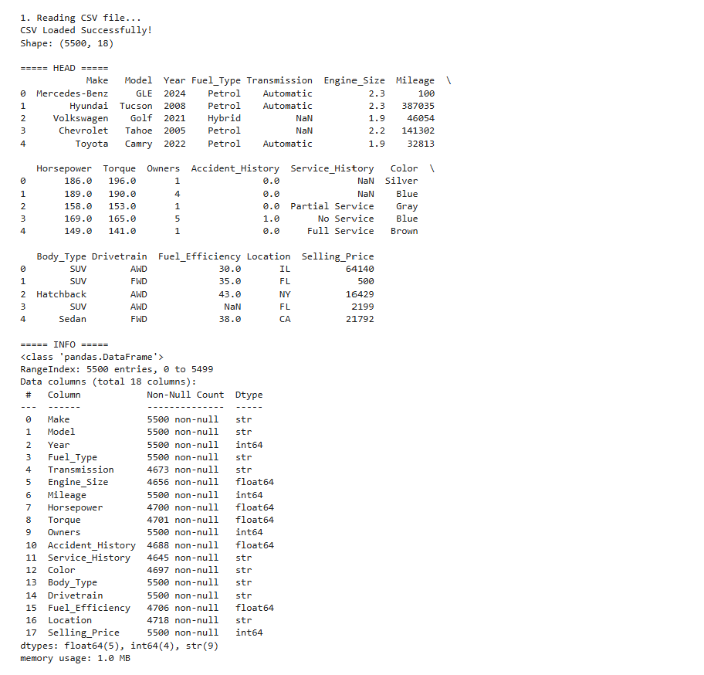
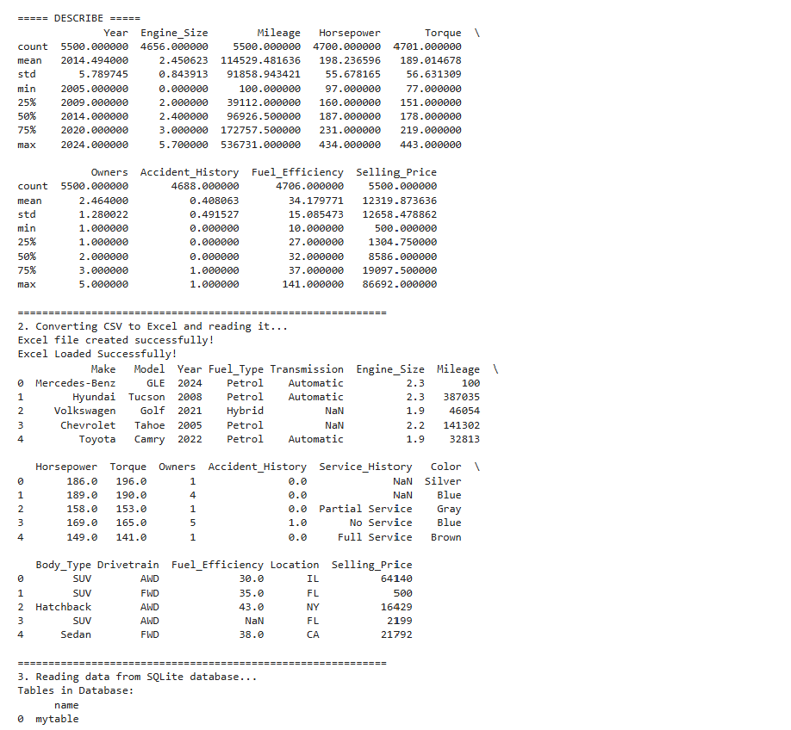
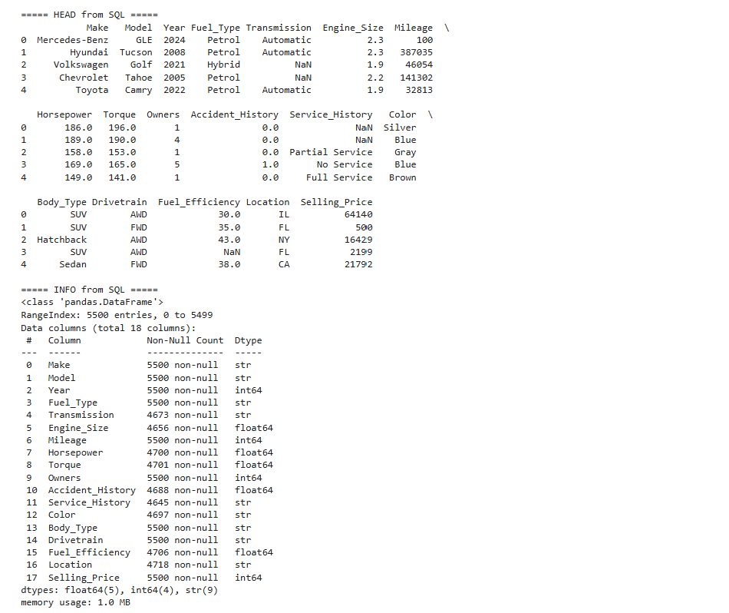
Result:

